
YEAR 12 CHEMISTRY - ATCHE

TASK 8: PRACTICAL ASSESSMENT 2021

Identifying Unknown Organic Compounds

Recommended time: 60 minutes
Total marks

/20
Suggested:

- Planning: 20 minutes
- Experimentation: 40 minutes

Name: _________________________________________

Teacher: _________________________________________

Introduction:

The identification and characterization of the structures of unknown substances are an important part of organic chemistry.

In this experiment you will carry out several qualitative tests that will allow you to identify functional groups in unknown organic substances. You will apply what you have learned by characterizing the unknown organic compounds in terms of their chemical reactions.

AIM:

The purpose of this investigation is to identify a set of unknown liquids. It will be necessary for you to plan
a series of physical and/or chemical tests to identify the unknowns provided and carry out the procedure.

You will be given SMALL liquid samples of

cyclohexene, ethanol, ethanoic acid and cyclohexane

each randomly labeled as A, B, C, and D. You will also be provided with common laboratory reagents including distilled water, bromine water (Br_{2 (aq)}), marble chips (CaCO₃), potassium permanganate (KMnO₄) solution and concentrated sulfuric acid.

Instructions:

1) Work out suitable experimental procedures to identify the substances.

Important note:

- Use very small amounts of the lab reagents (e.g. 1 mL) in any chemical reaction to enable them to be the limiting reactant.
- Reagents available are: distilled water, bromine water (Br_{2 (aq)}), marble chips (CaCO₃), potassium permanganate solution (KMnO₄) and concentrated sulfuric acid.
- Plan to do the ‘simple’ tests to the maximum number of unknowns, leaving the more complex tests to fewer numbers of unknowns to save time.
- You cannot use acid-base indicators or ester formation as one of your tests.
- If you work out the last chemical by elimination, conduct a chemical test to ensure its identity is correct.

2) Construct a flow chart in the Procedure section similar to the one illustrated below, to show your sequence of experimentation.

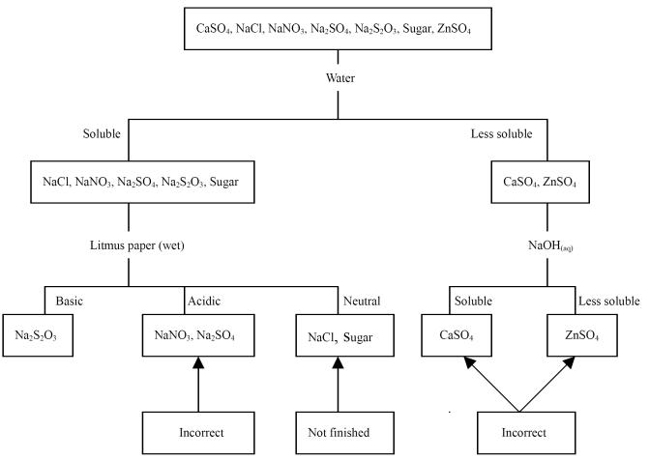

PROCEDURE:

Sequential flow chart (or dichotomous key): [2 marks]
A B C D

- (a) BRIEFLY describe all tests to be performed in the same sequence as your flow chart, noting how the result would identify the unknown: [4 marks]

(b) State two safety considerations which you need to make when conducting your experiments.
[2 marks]
_____________________________________________________________________________________

_____________________________________________________________________________________

_____________________________________________________________________________________

IN YOUR RESULTS FOLLOWING:

State all observations.

Write suitable chemical equations where possible to support your observations

Identify and state the chemical name of the unknowns.

RESULTS [12 marks]

Unknown sample A

1st Test performed
Observation (write nvr if no change occurs)
Inference (include a chemical equation where possible)

If required

2nd Test performed
Observation (write nvr if no change occurs)
Inference (include a chemical equation where possible)

3rd Test performed
Observation (write nvr if no change occurs)
Inference (include a chemical equation where possible)

4th Test performed
Observation (write nvr if no change occurs)
Inference (include a chemical equation where possible)

Conclusion:

Unknown sample A is

Unknown sample B

1st Test performed
Observation (write nvr if no change occurs)
Inference (include a chemical equation where possible)

If required

2nd Test performed
Observation (write nvr if no change occurs)
Inference (include a chemical equation where possible)

3rd Test performed
Observation (write nvr if no change occurs)
Inference (include a chemical equation where possible)

4th Test performed
Observation (write nvr if no change occurs)
Inference (include a chemical equation where possible)

Conclusion:

Unknown sample B is

Unknown sample C

1st Test performed
Observation (write nvr if no change occurs)
Inference (include a chemical equation where possible)

If required

2nd Test performed
Observation (write nvr if no change occurs)
Inference (include a chemical equation where possible)

3rd Test performed
Observation (write nvr if no change occurs)
Inference (include a chemical equation where possible)

4th Test performed
Observation (write nvr if no change occurs)
Inference (include a chemical equation where possible)

Conclusion:

Unknown sample C is

Unknown sample D

1st Test performed
Observation (write nvr if no change occurs)
Inference (include a chemical equation where possible)

If required

2nd Test performed
Observation (write nvr if no change occurs)
Inference (include a chemical equation where possible)

3rd Test performed
Observation (write nvr if no change occurs)
Inference (include a chemical equation where possible)

4th Test performed
Observation (write nvr if no change occurs)
Inference (include a chemical equation where possible)

Conclusion:

Unknown sample D is

